Oral Exam for Teams: Applied and Computational Math, 2013

Modeling the capillary rise: why is the meniscus curved?

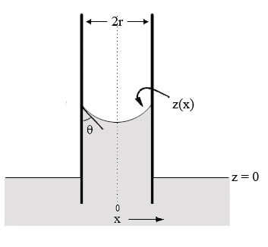
Water
Air
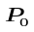
In a capillary tube, gravity and surface tension both act on water and a chemical equilibrium is attained (see the above Figure. We consider only the two dimensional case). The existence of surface tension caused a pressure difference on the surface, which leads to the capillary rise h and the curved surface z(x) with a contact angle 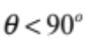. The contact angle is determined by the surface property of the tube and is given. The Young-Laplace equation is an equation that relates the capillary pressure difference sustained across the interface between two static fluids to the shape of the surface:

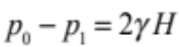

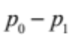 is the pressure difference across the air-water interface, is the surface tension,  is the curvature of the meniscus surface z(x). We also assume that is the density of the water, 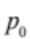is the atmospheric pressure, g is the gravitational constant and r is the radius of the tube.

In this question, , , r, , g, are given parameters. Our goal is to determine the shape of the surface z(x) and the capillary rise h.

(a). Calculate the pressure difference and curvature in terms of z(x) and then derive a differential equation for the meniscus surface 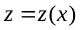.
(b). Design a shooting method to solve z(x) and determine h numerically. Explain analytically why the shooting method will work. Give the details of the numerical scheme.

